Hurricane Matthew - How can you help?

Over 1.4 million people in Haiti and 175,000 in Cuba have been affected by Hurricane Matthew. PWRDF has sent $40,000 for relief work in Haiti and a further $20,000 for relief work in Cuba through the ACT Alliance, whose members were active in both countries long before the hurricane and are there for the long term.
The major needs in Haiti are shelter, water, sanitation, hygiene and food. Cholera and the loss of crops and livelihoods are of particular concern.
In Cuba, the focus is on providing food security, water and sanitation, shelter and psychosocial support. Food for 30 days will be provided, as well as tools and seeds to help farmers to replant the crops that were destroyed.
Please support PWRDF’s response to this ongoing emergency!
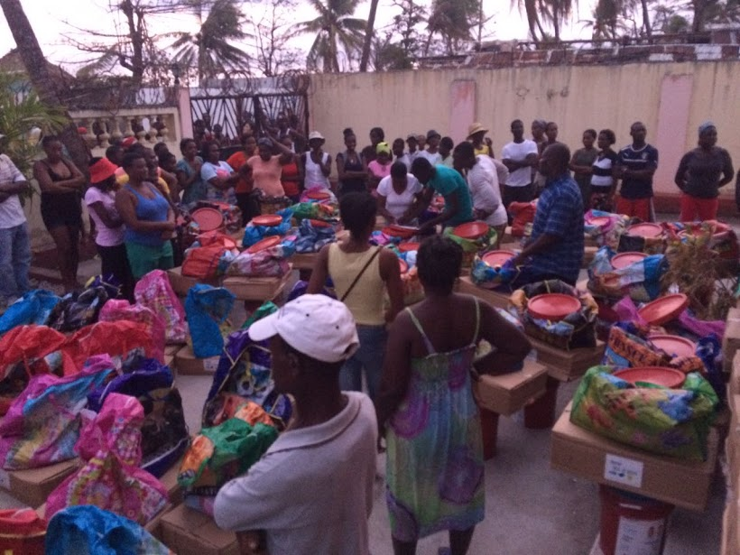
Food distribution in Haiti. Photo: FCA
Donations can be made in the following ways:
On-line
Go to http://pwrdf.org/donate

By Phone
For credit card donations contact:
Jennifer Brown
416-924-9192 ext. 355; 1-866-308-7973
Please do not send your credit card number by email or fax.

By Mail
Please make cheques payable to PWRDF, Haiti Response and send to:
The Primate's World Relief and Development Fund
The Anglican Church of Canada
80 Hayden Street
Toronto, Ontario M4Y 3G2
PWRDF Donations Contact:
Jennifer Brown jbrown@pwrdf.org
416-924-9192 ext. 355; 1-866-308-7973
PWRDF Humanitarian Response Coordinator
Naba Gurung
416-924-9192 ext. 321
ngurung@pwrdf.org
Anglicans in Canada are praying, acting and giving to those affected by Hurricane Matthew. Please watch for updates on PWRDF’s response to the situation at www.pwrdf.org.

